Design Model Document of

XMarket

Version <1.0>

Group 12

Table of Contents

Contents

List of Figures 4

**1. Introduction 5**

**1.1 Purpose 5**

**1.2 References 5**

**2. Design Model 5**

**2.1 Identify the object classes in the system 5**

**2.2 Choose the design model. 7**

2.2.1 The use case: Login 7

2.2.2 The use case view profile 8

2.2.3 The use case Learn Basic Lesson 8

2.2.4 The use case Practice Lesson 9

2.2.5 The use case Play Bubble Game 10

2.2.6 The use case Play Random Game 10

Index 13

# 

# List of Figures

Figure 1: The object classes 6

Figure 2 Two object classes derived from the abstract 6

Figure 3 Two classes inherited from Game class. 7

Figure 4 - System Environment 8

Figure 5 – User Use Cases 9

# Introduction

#### 1.1 Purpose

The purpose of this report is to present a detailed description on the Design Model of the XMarket Website System. This document is intended for both the stakeholders and the developers of the system.

#### 1.2 References

The report was completed following the book and documentation recommended and provided by Dr. Dang Duc Hanh including:

* The textbook Software Engineering 9th Edition written by Sommerville
* The series of lectures and slides of Software Engineering Course 2016 provided by Dr. Dang Duc Hanh.

# Design Model

#### 2.1 Identify the object classes in the system

From the requirements documenting steps, we determine what is the object classes in the website system. Then, we also identify the attributes and operations or methods for each class from the description of the system requirements documentation.

There are 3 main classes.

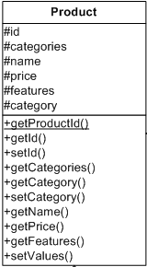 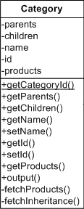

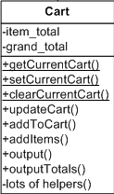

#### 2.2 Choose the design model.

In this project, we harness the design models in our system for showing the associations and relationships between the object classes in the system. The design model utilized in this project is **sequence model**, which describe the dynamic structure of the system and show the interactions between the system objects. The model is the bridge connecting the system requirements and the implementation of the project together.

We use UML to describe and visualize the interactions between the objects of the system by deploying the sequence model. Below are the significant use cases of the system where the users play the role of main actors.

##### **2.2.1 The use case: Login**

Description of Use Case:

The users log in to the website. Users type in their login info, the system check the database and decide whether the info is matched or not. If everything matched, the controller will load the view with data retrieved from database which is the reply to login request.

##### **2.2.2 The use case: Sign up**

Description of Use Case:

The users sign up to the website system.

Firstly, the users send request to the controller to register. The controller will ask user to provide some information. After checking if all info is legit, user’s info will be added to database. The model returns the data to the model User and then, the controller loads the view with the data retrieved which is the reply to the view profile request.

##### **2.2.3 The use case Search item**

Description of Use Case:

The users want to buy a product.

Firstly, the users type in the info of the product (or product name). The system will check the data of the product and returns the data to the model. Then, the controller loads the view) with the data retrieved which is the reply to the search item request.

##### **2.2.4 The use case: Checkout**

Description of Use Case:

The users picked their product. They want to finish their buying session by checking out.

Firstly, the users send checkout request to the controller by clicking the checkout icon. It pass the shopping cart info to the controller. The controller loads the view with the data retrieved which is the reply to the checkout request.

# 